EMBEDDED SYSTEM DEGINS EX6. FARID ALIJANI (0422513)

The idea of Exercise 6 is to design a PWM dimmer which turns on the led with different switches used as reference signals. The state machine concept has been used to implement the dimmer which has three states, including RESET, UPDATE and PWM.

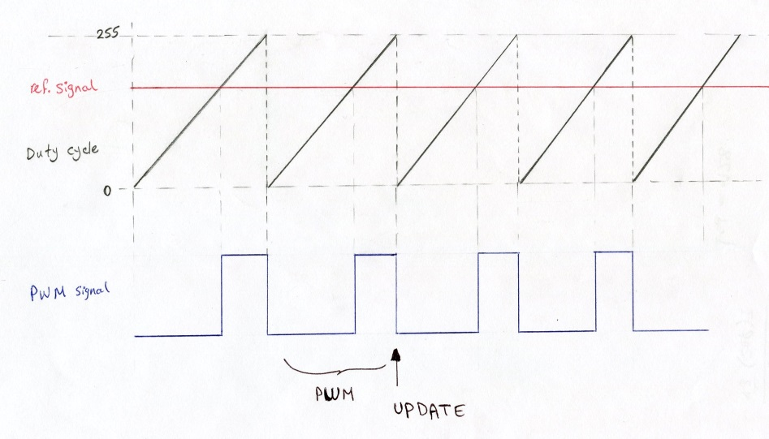

In the simulation, different switches have been tried as reference signals to observe the implementation of PWM on dimmer to light up the led.

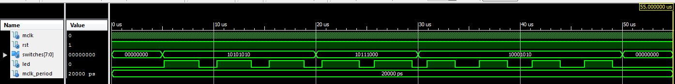

time < 5µs. : SWITCH OFF => LED OFF

5µs. < time < 20 µs. => SWITCH (10101010) => LED 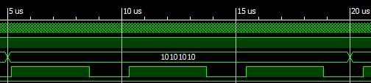

20 µs. < time < 30 µs. => SWITCH (10111000) => LED

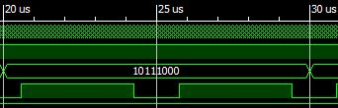

30 µs. < time < 50 µs. => SWITCH (10001010) => LED

